Chap 6 Programming Exercises Tyler Paulley

Exercise 5 & 6: Boolean Calculator

The two exercises that involved creating a Boolean calculator were combined. A sample run of the calculator is shown below.

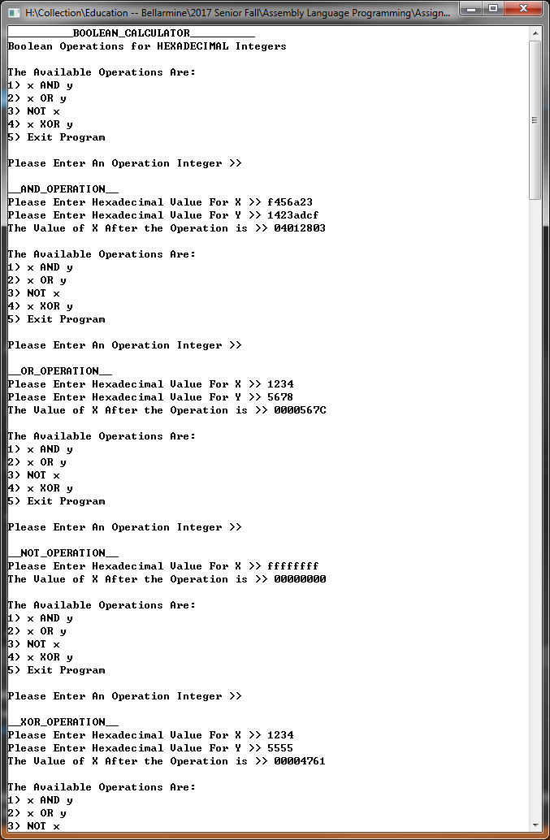

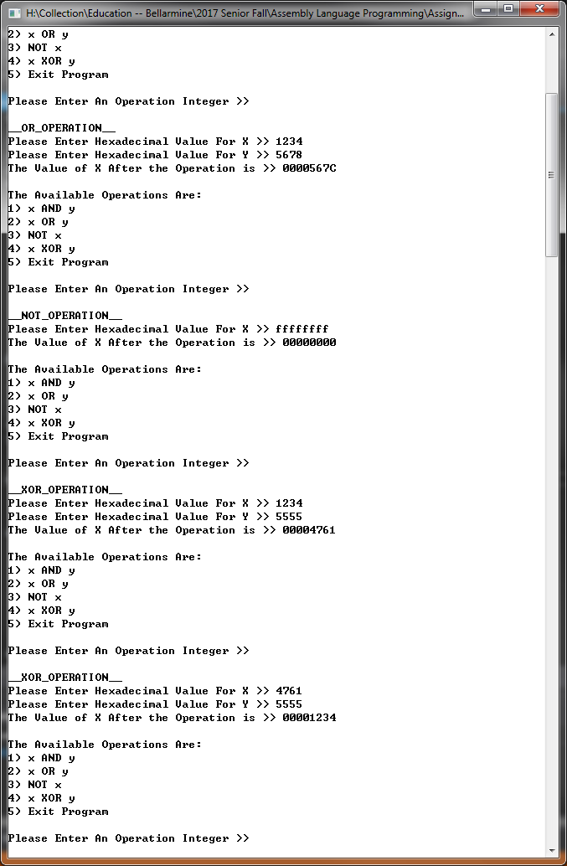

Exercise 8: Message Encryption

The output from a sample run of the code is show below.

